Practical 4
Part A
1) | Password strength (PasswordChecker.java + Driver.java)  (a) In PasswordChecker, check four rules — length ≥ 8, contains an uppercase letter,  contains a digit, contains a special character — using regex (e.g. “.*[A-Z].*”) or  String methods.  (b) Write strength(String pw) that counts how many rules pass and returns “Weak” (0–  1), “Medium” (2–3) or “Strong” (4).  (c) In Driver.main: test several passwords; for each, print which rules passed and the  final label.
 | PasswordChecker.java
Code | public class PasswordChecker {  static boolean[] rules(String pw) {  return new boolean[]{pw.length() >= 8, pw.matches(".*[A-Z].*"),  pw.matches(".*[0-9].*"), pw.matches(".*[^a-zA-Z0-9].*")};  }  static String strength(String pw) {  int count = 0;  for (boolean pass : rules(pw)) { if (pass) { count++; } }  if (count <= 1) { return "Weak"; }  if (count <= 3) { return "Medium"; }  return "Strong";  }  }
 | Driver.java
Code | import java.util.Arrays;  public class Driver {  public static void main(String[] args) {  String[] passwords = {"abc", "Abcd1234!", "abcd1234"};  for (String pw : passwords) {  System.out.println(pw);  System.out.println("Length, uppercase, digit, special: "  + Arrays.toString(PasswordChecker.rules(pw)));  System.out.println(PasswordChecker.strength(pw));  }  }  }
Output | 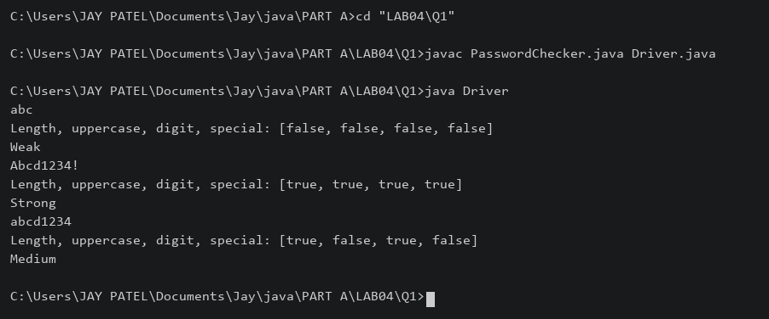

2) | Chat-log filter (ChatFilter.java + Driver.java)  (a) In Driver.main, define a String[] of log lines like “10:05 alice Hello there” (include  one malformed line with fewer than 3 parts).  (b) Read a keyword from the user.  (c) For each line, split into time/user/message with split(“ ”, 3); skip lines that do not  have 3 parts.  (d) If the message contains the keyword (case-insensitive), increment a counter and  append “time user: message” to a StringBuilder.  (e) Print “Matches: N” and the built report.
 | ChatFilter.java
Code | public class ChatFilter {  static String filter(String[] lines, String keyword) {  int count = 0;  StringBuilder report = new StringBuilder();  for (String line : lines) {  String[] p = line.split(" ", 3);  if (p.length != 3) { continue; }  if (p[2].toLowerCase().contains(keyword.toLowerCase())) {  count++;  report.append(p[0]).append(" ").append(p[1]).append(": ")  .append(p[2]).append("\n");  }  }  return "Matches: " + count + "\n" + report;  }  }
 | Driver.java
Code | import java.util.Scanner;  public class Driver {  public static void main(String[] args) {  String[] lines = {"10:05 alice Hello there", "10:06 bob Good morning", "bad"};  System.out.print("Keyword: ");  String keyword = new Scanner(System.in).nextLine();  System.out.print(ChatFilter.filter(lines, keyword));  }  }
Output | 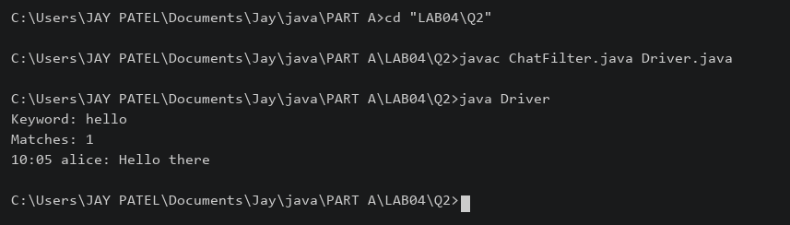

3) | (For Advanced Learners – home) Template filler (TemplateFiller.java +  Driver.java)  (a) In Driver.main, define a template like “Dear {name}, order {id} ships {date}.” and  two parallel arrays: names {“name”, “id”} and values {“Riya”, “A07”} (note {date}  is not supplied).  (b) Compile a Pattern for \{(\w+)\} and get a Matcher on the template.  (c) Walk the matches with a StringBuilder: for each {placeholder}, look up its value in  the names array and replace with the value, or with “[?]” if not found.  (d) Print the filled template.
 | TemplateFiller.java
Code | import java.util.regex.*;  public class TemplateFiller {  static String fill(String template, String[] names, String[] values) {  Matcher m = Pattern.compile("\\{(\\w+)\\}").matcher(template);  StringBuilder result = new StringBuilder();  while (m.find()) {  String value = "[?]";  for (int i = 0; i < names.length; i++) {  if (names[i].equals(m.group(1))) { value = values[i]; break; }  }  m.appendReplacement(result, Matcher.quoteReplacement(value));  }  m.appendTail(result);  return result.toString();  }  }
 | Driver.java
Code | public class Driver {  public static void main(String[] args) {  String template = "Dear {name}, order {id} ships {date}.";  String[] names = {"name", "id"};  String[] values = {"Riya", "A07"};  System.out.println(TemplateFiller.fill(template, names, values));  }  }
Output | 

